WEEK-08-SORTING ALGORITHMS-BUBBLE AND SELECTION

WEEK 08-01-PRACTICE SESSION CODING REG NO : 240901065

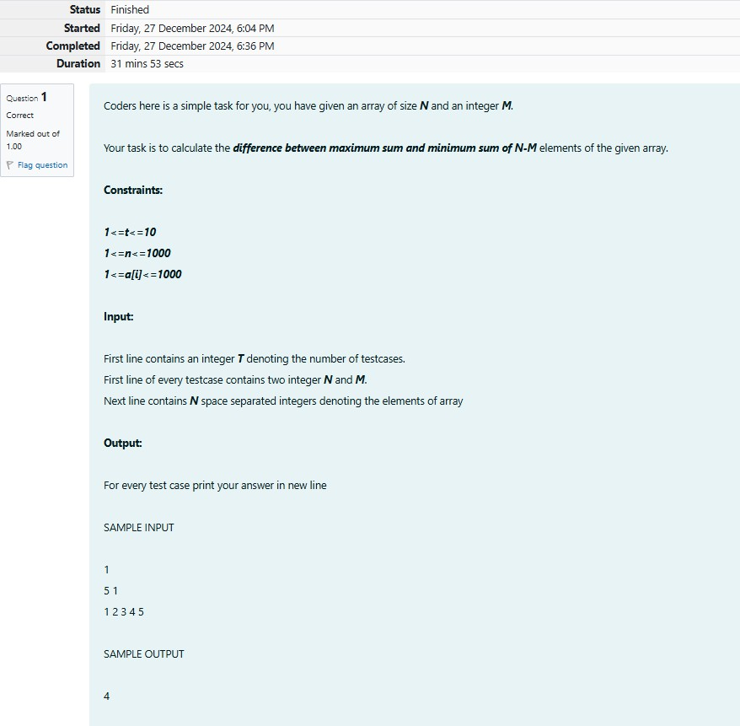NAME : NETHRA P Q1)

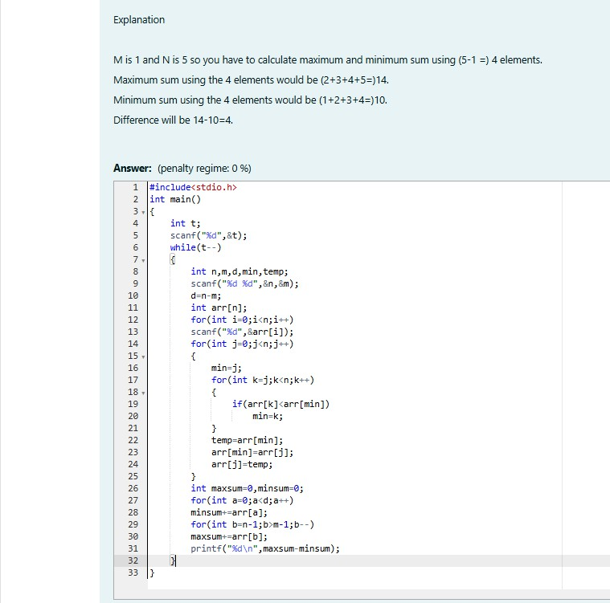

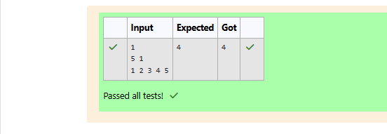

WEEK 08-01-PRACTICE SESSION CODING

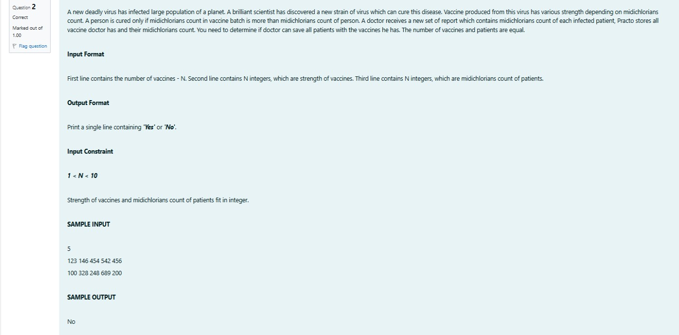REG NO : 240901065 NAME : NETHRA P Q2)

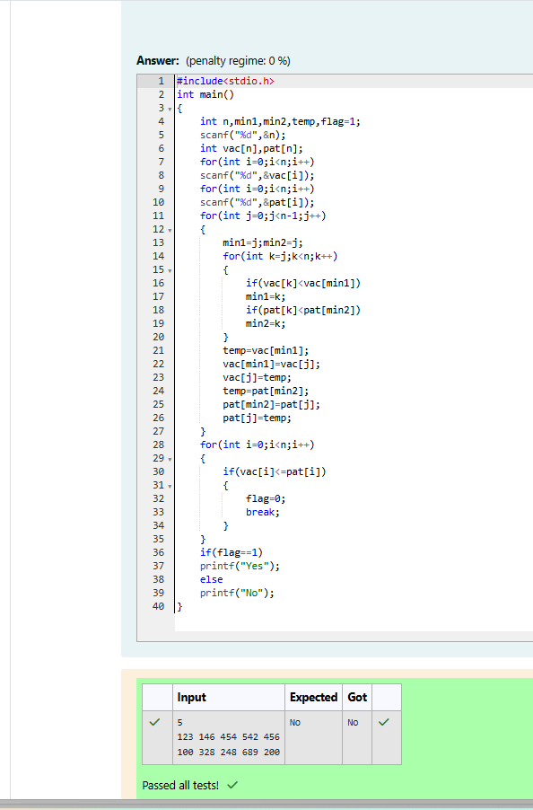

WEEK 08-01-PRACTICE SESSION CODING REG NO : 240901065

NAME : NETHRA P Q3)

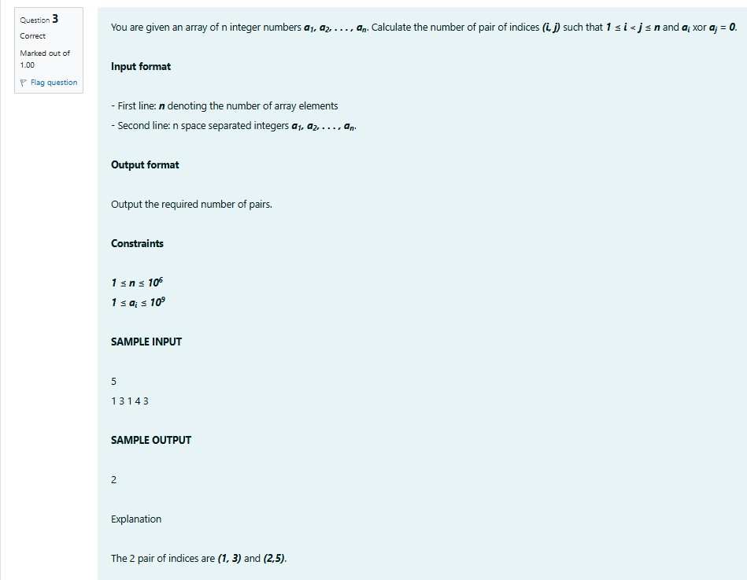

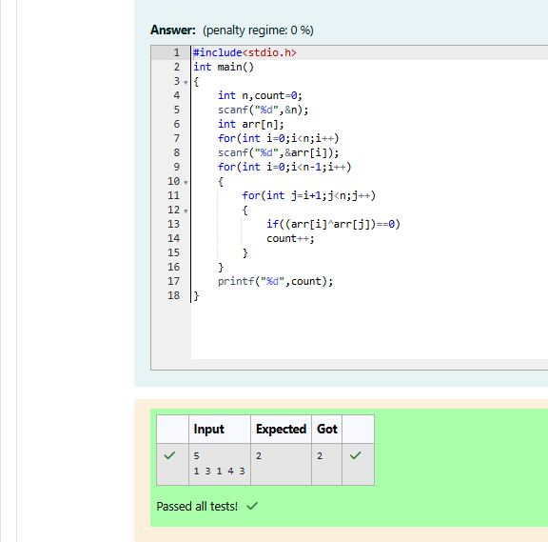

WEEK 08-01-PRACTICE SESSION CODING REG NO : 240901065

NAME : NETHRA P Q4)

